
O

Forms

Migrant Education Program

EXITO

- Name:_ _ _ _ _ _ _ _ _ _ _ _ _
- Date of Birth:_ _ _ _ _ _ _ _ _ _
- County: _ _ _ _ _ _ _ _ _ _ _ _

EXITO ~ Parent: Training Check List

Parent Name(s): __________________________________________________________________________
Child Name: ______________________________________________________ Date: _________________
Trainer Name: ___________________________________________________________________________
(Please place your initials in the box after you have explained or completed the task)

- Build a relationship of trust ~ get to know the parent(s). Take some time to explain why you are there and how you wish to empower them to be able to better prepare their children for school. Explain the importance of language development of the concept of prior knowledge. If children know all of the colors, numbers, shapes, and body parts in Spanish, it will be a lot easier for them to transfer that knowledge to English.

- Explain to the parent(s) that you are not going to be teaching their children ~ you will be teaching them how to teach their children.

- Tell them about the importance of the skills that they will be teaching: Numbers, colors, shapes, alphabet, & body parts.

- Explain that the purpose of the program is to train them to effectively “play” with their children and to help them learn what they need to know, as parents who are supportive of their children’s education. Also, explain that if they do not do the activities with their children, you will not be able to do follow-up visits.

- If the parent(s) agree(s) to work with their child(ren) to help them master these subjects, have them sign the Agreement Form and give them a copy. Ask permission to pre-test the child.

- Test the child(ren) using the Child Evaluation Checklist as a pre-test. Make it a game. They do not need to know they are being tested. Evaluate each child independently.

- Explain to the parent(s) the results of the evaluation.

- Depending on the mastery level of the child(ren), let the parents know how many visits you would like to make. For example, if they have mastered two of the subjects, then instead of 10 visits you would then you would only have 6 visits to complete) # of Visits: ________________________________________

- Answer any questions.

EXITO ~ Parent: Home visit LOG sheet

Parent Name(s): __________________________________________________________________________
Child Name: ___________________________________________________________________________

Trainers: Keep a log sheet on each family to refer back to. Make notes on how interested the parent/child was, how the children seemed to respond, progress noted in either the child or the parent. Update this log sheet after each visit with the date and the length of the vist(s). Always make a note of the date of the last visit in your notes.

______________________________________________________________________________________________________________________________________________________________________________________________________________________________________________________________________________________________________________________________________________________________________________________________________________________________________________________________________________________________________________________________________________________________________________________________________________________________________________________________________________________________________________________________________________________________________________________________________________________________________________________________________________________________________________________________________________________________________________________________________________________________________________________________________________________________________________________________________________________________________________________________________________________________________________________________________________________________________________________________________________________________________________________________________________________________________________________________________________________________________________________________________________________________________________________________________________________________________________________________________________________________________

EXITO ~ Child: Evaluation Checklist (Administered as a Pre-Test)

Child Name: ___________________________________________________________________________
DOB: ____________________________________________Date: _____________________________

Numbers
- The child visually recognizes the following numbers (circle):
1 2 3 4 5 6 7 8 9 10
- The child can count to ____________ (1-10) without verbal prompting
- The child doesn’t count

Colors
- The child recognizes the following colors (circle):
Red Orange Yellow Green Blue
Purple Black Brown White Pink

Letters
- The child can recite the alphabet with or without (circle) verbal prompting
- The child recognizes the following letters of the alphabet (circle):
A B C D E F G H I J K L M
N O P Q R S T U V W X Y Z

Shapes
- The child recognizes the following shapes (circle):
Square Rectangle Triangle Circle

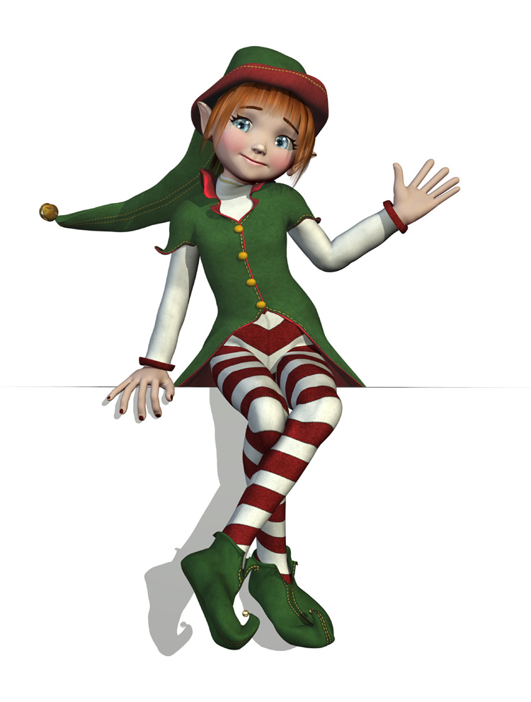
Body Parts

- The child knows the following parts of his/her body and can point at the corresponding part and say what it is (circle):
Head Arms Legs Nose Shoulders Eyes Ears Mouth
Toes Fingers Hands Knees Elbow Stomach Feet
- The child can point to the following body parts but cannot say the name (circle):
Head Arms Legs Nose Shoulders Eyes Ears Mouth
Toes Fingers Hands Knees Elbow Stomach Feet

EXITO ~ Parent Pre-Training Survey

Parent Name(s): ___________________________________________________ Date: _________________
Trainer Name: ___________________________________________________________________________

- How often do you read to your child?
- 1 time a week
- 2 times a week
- 3 times a week
- 4 or more times a week
- I never read to my child
- Do you have appropriate level reading books in your home for you to read to your child?
- Yes
- No

- Are you aware of what skills your child needs to know in order to be prepared for kindergarten?
- Yes
- No

- Have you worked with your child on any of the following topics (please circle all that apply)?
Numbers Letters Shapes Colors Body Parts
- Do you have any ideas on how to teach these subjects to your child?
- Yes
- No
- Do you think it is important to teach your child in Spanish?
- Yes
- No
- At what age do you think it is important to start working with your child on building learning skills?
- 1
- 2
- 3
- 4
- 5
- 6 or older
- Is there anything you are particularly interested in learning related to ideas on how to work with your child?_______________________________________________________________________

EXITO ~ Parent Post-Training Survey

Parent Name(s): ___________________________________________________ Date: _________________
Trainer Name: ___________________________________________________________________________

- How often do you read to your child?
- 1 time a week
- 2 times a week
- 3 times a week
- 4 or more times a week
- I never read to my child
- Do you have appropriate level reading books in your home for you to read to your child?
- Yes
- No

- Are you aware of what skills your child needs to know in order to be prepared for kindergarten?
- Yes
- No

- Have you worked with your child on any of the following topics (please circle all that apply)?
Numbers Letters Shapes Colors Body Parts
- Do you have any ideas on how to teach these subjects to your child?
- Yes
- No
- Do you think it is important to teach your child in Spanish?
- Yes
- No
- At what age do you think it is important to start working with your child on building learning skills?
- 1
- 2
- 3
- 4
- 5
- 6 or older
- Is there anything you are particularly interested in learning related to ideas on how to work with your child?_______________________________________________________________________

Exito ~ Roster/Checklist

Student: _______________________________________________________________________________________
Grade:_________________________ Age: _________________________ Sex: ___________________________
Address: __________________________________________________ Phone: _____________________________
Number of Visits:___________________________________________ Parents Interested:  Yes  No

 | Date | Comments
COLORS
Visit 1
Visit 2
SHAPES
Visit 1
Visit 2
NUMBERS
Visit 1
Visit 2
ABC
Visit 1
Visit 2
BODY PARTS
Visit 1
Visit 2

